Innovation Toolkit / Discovery Sprint

Discovery Sprint — May 2016

***18F*** *— Alan Brouilette, Amy Wilson (PIF), Britta Gustafson, Fureigh, James Hupp, Jeremy Zilar, Tom Black*

*A growing number of Federal employees are using new approaches to solve problems, improve the core processes of government, and foster innovation. However, adoption of these approaches is still low relative to their potential. Many Federal employees do not know that these approaches exist or lack the support needed to use them effectively.*

*The Administration is creating an Innovation Toolkit to facilitate the broader adoption and awareness of a core set of innovative approaches. The Innovation Toolkit will consist of high-quality online resources that explain how and why these approaches can yield important results for the American people.*

*—* [*A Strategy for American Innovation, October 2015*](https://www.whitehouse.gov/sites/default/files/strategy_for_american_innovation_october_2015.pdf) *(109–110).*

### Table of contents:

Table of contents:

What we set out to discover

Questions this sprint answered

Our approach

What people need

Authoritative guidance for legal compliance issues

They are looking for:

Real sample documents from other people’s implementations of these approaches, as models to reuse and adapt

They are looking for:

Replicable examples with explanations of operational structures and policies

They are looking for:

Connections to other people who are doing related work

They are looking for:

Concrete examples of how others measure effectiveness and ROI

They are looking for:

Support for being effective at leading change

They’re looking for:

Where and how they look for information about effective approaches

They often pick up the phone and call somebody or email them

They work closely with stakeholders in their agencies

They cast a wide net to learn from a broad variety of resources

Operational challenges for the toolkit itself, based on what people said

People get an inaccurate first impression from the term “Innovation Toolkit”

There are barriers to sharing knowledge about effective approaches

People play multiple roles in any given process.

The innovators are also often the people looking for innovative practices.

People need conversation and human interaction to make connections.

Hypothesis: these multiple roles can be quite useful.

A few things we learned about hiring

What we learned

Unique hiring programs

Digital service concept that would serve these needs

Person to serve as a point of contact, who can lead iteration

Search-engine-friendly public mini-site within DigitalGov.gov that seeks out and publishes targeted content meeting expressed needs

Non-public (government-only) site to accompany the public Innovation Toolkit site

Run an accompanying community: a listserv and outreach events with facilitation to support ongoing networking and contribution

Table of contents:

What we set out to discover

Questions this sprint answered

Our approach

What people need

Authoritative guidance for legal compliance issues

They are looking for:

Real sample documents from other people’s implementations of these approaches, as models to reuse and adapt

They are looking for:

Replicable examples with explanations of operational structures and policies

They are looking for:

Connections to other people who are doing related work

They are looking for:

Concrete examples of how others measure effectiveness and ROI

They are looking for:

Support for being effective at leading change

They’re looking for:

Where and how they look for information about effective approaches

They often pick up the phone and call somebody or email them

They work closely with stakeholders in their agencies

They cast a wide net to learn from a broad variety of resources

Operational challenges for the toolkit itself, based on what people said

People get an inaccurate first impression from the term “Innovation Toolkit”

There are barriers to sharing knowledge about effective approaches

People play multiple roles in any given process.

The innovators are also often the people looking for innovative practices.

People need conversation and human interaction to make connections.

Hypothesis: these multiple roles can be quite useful.

A few things we learned about hiring

What we learned

Unique hiring programs

Digital service concept that would serve these needs

Person to serve as a point of contact, who can lead iteration

Search-engine-friendly public mini-site within DigitalGov.gov that seeks out and publishes targeted content meeting expressed needs

Non-public (government-only) site to accompany the public Innovation Toolkit site

Run an accompanying community: a listserv and outreach events with facilitation to support ongoing networking and contribution

# What we set out to discover

In October of last year, the White House’s *Strategy for American Innovation* identified a problem:

*A growing number of Federal employees are using new approaches to solve problems, improve the core processes of government, and foster innovation. However, adoption of these approaches is still low relative to their potential. Many Federal employees do not know that these approaches exist or lack the support needed to use them effectively.*

Early coordinated efforts such as the Citizen Science and Crowdsourcing Toolkit have already had great effects. The next step is to figure out how to make this broader toolkit project effective, as stated in the Great Pitch proposal:

*The key risk facing any effort to create knowledge-sharing resources is that the resources may be underutilized by intended users. A user-centered design approach will be required to ensure the Toolkit’s resources meet user needs, as will complementary efforts to market these resources to users.*

We set out to discover how this toolkit could be built to effectively serve the many talented federal employees **scattered across many agencies who have motivation and potential to cause change**. This includes innovation lab leaders and participants, people in fellowship programs, and people anywhere else in the federal government who take formal or informal leadership roles supporting effective new approaches.

**We investigated these core questions:**

* What resources does the target audience need to support their work when trying new approaches?
* What gaps do they see in the available resources?
* What are the current ways they look for the kinds of information the toolkit would support?
* What barriers stop them from using innovative approaches, including barriers to finding key resources?

To get a deeper picture of how people research specific solutions to problems, we also investigated how people learn about a specific area of the Innovation Toolkit as listed in the Strategy for American Innovation: *“Rapidly hiring top talent using flexible hiring authorities and accelerated hiring practices, particularly for areas where there is a significant gap between world class performance and current public-sector practices.”*

# Questions this sprint answered

The Great Pitch proposal makes the case for a centralized online resource that gives people the tools they need to solve problems. We found that **people use a complex combination of offline and online methods to address their needs for information**. This means we need to think of serving these needs as building a “digital service” ([addressing the whole user experience from start to finish](https://playbook.cio.gov/#play2)) within the larger experience of OCSIT’s offerings that support the transfer of important operational insights between federal employees.

Based on our research and interviews with people seeking and sharing information about innovative approaches, here are some of the most important things we learned about how to build an effective toolkit:

* People heavily depend on their human networks, since there’s nothing like talking to a person who has been in a similar situation or is a SME on your question. The toolkit can serve this existing system by helping onboard more new people into those networks, with the help of key useful documents and points of contact. The toolkit can help people find the right SME faster rather than having to take a lot of hops through a network.
* Give people model/sample documents that they can reuse and adapt to build their own programs. They often don’t need laboriously researched and detailed how-to guides; they can figure out a lot of the core topics.
* There’s no way to make a central authoritative convincing document that will fully help a person convince a supervisor to implement an approach -- interpretations are very team and agency based. Resources from other reputable agencies are helpful to start conversations though.
* People need access to authoritative interpretations of law/policy/regulation, not just pointers to the relevant law/policy/regulation. Help people prepare for tough conversations with lawyers and GAO.
* People need general support on how to accomplish change management -- how to convince supervisors.
* When we discussed this project with people unfamiliar with the concept and introduced it with the term “Innovation Toolkit”, they often first took the direction of thinking that it was a general toolkit for how to build a culture of innovation (rather than a specific set of tools).

# Our approach

* **We interviewed a range of targeted users: people with formal and informal leadership roles who learn about and implement innovative approaches.** We spoke to 15 people across 12 agencies, including seven people working in innovation labs and three people in innovation delivery teams (18F and USDS).
* **With 18F’s project intake group, we reviewed requests that 18F received from agencies seeking help with innovation issues.** This included looking at client intake emails, general emails, and relevant emails sent to our talent team members. We read emails from federal employees asking for 18F’s advice and suggestions related to innovative practices such as accelerated hiring.
* **We discussed this work with a range of 18F staff who work with many agency partners.** We learned what teams across 18F had observed from those partners about the challenges of innovating in their agencies.
* **We explored the landscape of existing work.** We examined existing government toolkits for patterns and concepts, and we assessed what content currently helps spread information about the practices identified for the Innovation Toolkit.
* **We looked over recent user interviews done by the** [**Transformation Research discovery sprint team**](https://github.com/18F/transformation-research)**.** This is a current 18F project researching the related topic of digital transformation in government. Some of their interviews are relevant to our focus as well.

# What people need

Our research identified several common themes among the needs expressed by the Toolkit’s audience. We represent these needs in ten user stories. These statements — describing a person’s role, what they need, and why they need it — provide flexibility. A broad solution can be built to address that need immediately, or a team can do further research and craft a more refined solution.

## Authoritative guidance for legal compliance issues

|  |
| --- |
| **User story A:** As a person trying to innovate within the legal and policy bounds of my agency, I need authoritative guidance (including references to specific helpful policies) for how to deal with burdensome and sometimes outdated requirements while complying with the law, since right now requirements from “higher up” authorities frequently block me when I try new approaches. |

### They are looking for:

* All kinds of authoritative legal guidance for taking innovative approaches while complying with a broad range of legal requirements from many sources.
  + *“People ask us for guidance for interacting with OGC, legal, policy, labor unions, hiring authorities...”*
  + *“We need a place where there are legal interpretations written by an authoritative source - where if somebody wants to leverage that, they can point to that. Procurement policies, digital services things: 508, PRA, ATO.”*
* Explanations that are convincing to lawyers across many agencies.
  + *“These things are only really helpful if they’re not agency-specific. GSA tends to get away with things the rest of government can’t. Maybe if this resource explained how they get away with it: what to tell the lawyers!”*
* How to be prepared for what oversight officials (such as IG offices and GAO) may request from them.
  + A person suggested interviewing oversight and accountability officials to find out what *they* need to see to be convinced that innovative approaches are effective.
* Examples of guidance needed:
  + How to comply with the Federal Acquisition Regulation while doing modern digital work.
    - *“I want policy guidance. Reference the FAR or the law. Talk about how appropriations are set up and what they’re based on.”*
    - *“The U.S. Digital Services Playbook was great because it actually addressed how FAR interacted with digital work.”*
  + How to work within the constraints of the Paperwork Reduction Act while doing modern digital work.
    - *“The social media guidance from the White House that clarified PRA doesn’t apply to the use of, say, login info like usernames and passwords — that was really helpful.”*
  + How to speed up the Authority to Operate process.
    - *“There are lots of things built in the lab that work well and would save lots of money, but then they need to go through the regular ATO process, which takes forever. How do we transfer innovative ideas to a production pipeline better and faster?”*
* Ways to figure out what software is compliant so they know what their options are.
  + *“The list of services with government-compliant Terms of Service on DigitalGov — that’s the only thing I’ve used from that site.”*

## Real sample documents from other people’s implementations of these approaches, as models to reuse and adapt

|  |
| --- |
| **User story B:** As a person exploring how to fit innovative approaches into my office’s or agency’s setting, I want to see examples of process documents other people are using to implement innovative approaches (such as Memoranda of Understanding, Interagency Agreements, position descriptions, handbooks, internal policies, memos, software lists, and other documents) so that I have real models to help me start conversations and adapt for my own work. |

### They are looking for:

* Internal policies for using tools that support innovative work.
  + *“Is there a write-up on use of / creation of GitHub accounts for 18F staff? Curious as to the policy on tying one’s account and activity to a work email address vs. coming into 18F with a personal account already created. The more I can point our developers to assets/policies you create, 1) it makes my life easier so that I don’t have to recreate the wheel; and 2) it helps ensure we’re all in-line and building a federal-wide standard to working.”*
  + *"A set of (say) 100 VPATs – that is, the forms that respond to Section 508 – that federal agencies have found to be acceptable. Vendors often write them, and for open source programs there is often no vendor. Without one, a software may be rejected/blocked for use within an agency, or configured in a way that’s not best for disabled people...I struggled to write one myself for git"*
* Examples of contracts between other agencies for trying new things.
  + *“I want a set of (say) 50 Memoranda of Understanding (MOUs) between agencies, so I have a sense in advance of what can be accomplished that way and how difficult it is. Innovation is cheaper and easier if I can use info from other agencies, and if don’t spin my wheels forever trying to get it.”*
* Lists of tools agencies use for doing work.
  + *“Lists of what software other agencies are running (leaving out anything that they wish to keep secret). At the moment two interesting areas are what the agencies use for data science, and what wiki software they run.”*
  + We asked a person “What if 18F published lists of software it uses?” *“Yes! Especially if you published lists of software and services you use that are free. apps.gov is helpful but it’s just stuff that can be procured.”*
* Basic “building block” software tools for open data work.
  + *“A low cost way to do this would be to post the source code for basic programs to interpret/diagnose/use JSON-format data and work together on them. A lot of this has been done but I don’t know of an easy 6ntro to it."*
* Memos that establish authorities or document decisions.
  + When 18F staffers informally answers questions from people at other agencies about how to use Schedule A(r) hiring authority, one thing they sometimes offer to show as an example is the GSA memo that was required as part of that process.

## Replicable examples with explanations of operational structures and policies

|  |
| --- |
| **User story C:** As a person who needs to tell effective stories about how innovative goals are accomplished, I want to see case studies of other agencies’ work — successes as well as lessons learned — so I can learn from their experiences, see what’s possible, persuade my stakeholders that there’s precedent for this work, and know who to try to connect with for further details. |

|  |
| --- |
| **User story D:** As a person doing work that is new for my agency and sometimes for myself, I want practical explanations of best practices and operational information so that I can with confidence support or carry out ventures that may be unfamiliar - by borrowing from validated examples. |

|  |
| --- |
| **User story I:** As a person with limited time and resources, I want to see what resources, groups, etc. already exist so that I can avoid reinventing the wheel. |

### They are looking for:

* Enough information about similar projects to be able to decide whether to make changes to their own work.
  + *“For their internal competition, they looked at HHS and private sector companies. They iterated and moved to a more gated process like the intelligence community.”*
* Convincing stories from experts with attached policy and operational information.
  + *“Not able to change the world but was able to get interesting speakers in to address the bureau. Personal stories from experts more helpful? Yeah. especially if a policy is attached. Easier to grab on if it’s happening in another agency. They see a structure that works. They believe it works.”*
  + *“10 10-15-minute segments where federal employees come in and talk about their project or initiative. Seeing other people apply design process has been kind of key.”*
* Ordinary proven examples, rather than flashy entirely-new examples.
  + *“One of the biggest challenges is a lot of people say ‘Well, isn’t this something that just comes from outside? It’s not really going to work here.’ … Projects that aren’t as innovative as an outsider might think, they’re really much more effective at showing the possibility of this stuff. Most people aren’t building a new rocket ship, they’re building a new form or a new way of collecting data.”*
* Context that shows what new approaches are really capable of.
  + *“(Design) can accomplish a great deal more than running a meeting or planning a strategy around a particular initiative. One thing that has been difficult is showing examples where design can be both process based and organizational culture based.”*
* Guidance that is more authoritative rather than just anecdotal.
  + *“Not just best practices, since they vary from agency to agency”*
  + *"One of the biggest challenges is where do I get more info to learn from and continue to grow that is* ***validated****. Runs the gamut from 18F, USDS, counterparts."*
* How other programs operate.
  + People consistently reported that they set up interviews/meetings with people they know are doing interesting work and ask “How do you operate your program? How do you set it up?”
* International equivalents to what they’re doing.
* *“He used a guide from innovation folks in England that talked about challenges to help him get started with his own guide. Borrowed the best bits.”*
* *“I go to a lot of conferences...they help for finding international data and evidence. The things our agency does are closely related to work other government institutions in other countries do, and we want to know what their programs look like.”*
* One of us went to a talk by a person who worked on the [Australian government “innovation toolkit”](http://innovation.govspace.gov.au/); he said the most helpful aspect of that toolkit was helping people find precedents to point to at other agencies, and that their monthly meetings also helped build important connections. This Australian experience was valuable context for our team.

## Connections to other people who are doing related work

|  |
| --- |
| **User story F:** As a person working in areas where my agency is not used to innovating, I want to know who else is doing this work well so that I can more easily make direct contact with them. Direct contact gives me a better sense of community and where to turn when organizational challenges arise for me. It also educates me about what’s worked for them, the resources they have, etc. |

### They are looking for:

* People who are working on similar things and have similar expertise in other agencies.
  + For example, how to find a person who has experience in managing a shared cloud experiment resource for staff, or a person who knows what inventions have been invented to measure a specific chemical.
* Connections to contacts who can offer basic guidance as they get started.
  + *"Within OCSIT & 18F, there should be a tier 1 - tier 4 sort of support. Basic services, freely accessible - then moves up to the level of hand-held direct services provided. There has to be a better structure in place to sort of guide people who don’t know necessarily how to navigate it but short of the SWAT team."*
* Connection to other people doing similar work and emotional support.
  + *“People have struggles about feeling alone in their team or agency.”*
* Opportunities to learn and share across teams more.
  + *“I probably could do more in getting out of my office. That’s what I find a lot of people doing. A lot of people are doing some really cool stuff, and then they have no idea what their neighbor, what 18F across the street is doing. Where I’ve been successful is just saying yes to going to stuff or participating in stuff.*
* Being part of a growing movement of innovative practices that sustains knowledge over time and integrates it into gov.
  + *“Processes like open source and human centered design can actually become a new paradigm for how government operates, just like anything else. But without the crowd, how do you support that and sustain it?”*

## Concrete examples of how others measure effectiveness and ROI

|  |
| --- |
| **User story E:** As a person managing an innovation program, I need examples of quantitative metrics other people have used to demonstrate the value of their work. |

### They are looking for:

* How other people measure the results of these innovative programs.
  + *“The private sector measures (money etc) don’t work so well in gov. Constantly struggling to find non-qualitative ways to describe what success looks like.”*
* How innovative approaches have *not* succeeded, which requires identifying real definitions of success and failure.
  + *“Show where it’s worked, how, and why. Use cases are great. Try to draft those. We also ask people to tell us about successes and failures because you can learn from failures.”*

## Support for being effective at leading change

|  |
| --- |
| **User story G:** As a person trying to convince leadership at my agency to adopt innovative approaches, I need support for navigating bureaucracy, change management, and more so that the whole organization can align in one direction. |

### They’re looking for:

* How to convince their leadership to support these ideas.
  + *“What would help? How to convince your boss.”*
  + *“If a person at the top gets an idea, it can move forward.”*
  + *“Change the mindset. Comes down to leadership, support, changing minds.”*
* Templates that do more than serve as instruction manuals, that lead to the embrace of challenging thinking.
  + *“We do a lot of education and outreach, but your really need people at various levels of an org willing to try things and they still require assistance. And they require templates they like...Templates are great, but we want to get out of that phase and get into critical thinking phase.”*
  + *“Challenge: teaching the mindset of design, which people love and are attracted to. But then a lot of people also just want a tool. They literally want a template they can print out and run through an activity over the course of an hour to navigate through a difficult challenge or developing something new.”*

### They could use more support for their existing change strategies.

* They recognize that mindsets need to be addressed head on.
  + *“Unfortunately, in some organizations, you don’t always have a lot of people who get it or want to change. Some folks may think you’re meddling. There’s a status quo mentality. Then there’s folks who want to make changes but don’t know how.”*
* They want more partnership in their dialogues with authorities who can make changes to important operational issues:
  + *“There is a huge need for us to have a (collective) conversation with OPM, OMB, and Congress. Agencies are not actually working together in dealing with those three key stakeholders much. All of our dialogue with them feels lonely and there could be a lot more.”*

# Where and how they look for information about effective approaches

|  |
| --- |
| **User story K:** As a person trying to figure out how to get innovative work done, I strongly rely on conversations with experts and my network of contacts to get truly useful and practical information. |

## They reach out directly to the people they have heard might help

* They often pick up the phone and call somebody in another agency and ask them to look for information within their agency. The cross-lab network helps innovators connect to innovators in other agencies.
  + *“Hub and spoke — call one person at an agency and ask them to look within their agency.”*
  + *“It’s a treasure hunt…Wouldn’t know who to contact at the CDC if I didn’t know the HHS Idea Lab people.”*
  + People contact somebody who might know a person who might know a person and ask them to forward it along - “six degrees of separation” style
* They email people they hear are experts. 18F’s Director of Talent Jen Tress gets a lot of this kind of email, for example.

## They work closely with stakeholders in their agencies

|  |
| --- |
| **User story K:** As a person doing innovation work, I need to work in harmony with the other people at my agency and elsewhere who are already working on these things, so I need strategies for how best to work with them. These strategies may be wildly different depending on the team and situation. |

* Some announce intentions and see who complains.
  + *“I shout all the things I am going to do with as much detail as possible to try and root out all the people who are going to stop me. Then I work with each person to get it resolved. Most effective strategy I’ve found.”*
* Some bring stakeholders in as early as possible.
  + *“The way it should be at the beginning when you’re developing your needs, there should be a collaborative framework with all stakeholders internally to see what else is out there internally. Include budget, procurement, who you’ll be working with, IT, and security, so everyone is aware.”*

|  |
| --- |
| **User story H:** As a person doing innovation work, when I look for one resource I want to see related materials and groups that could also be useful for that purpose so I can do my work most effectively. |

|  |
| --- |
| **User story J:** As a person doing innovation work, I want to see resources I might not have been immediately looking for so I can broaden my skillset without having to know everything that there is to be learned. |

## They cast a wide net to learn from a broad variety of resources

* Most of them subscribe to at least some government listservs (including outside their specific area of expertise) although they find them of varying usefulness.
* Some of them go to interagency meetings, conferences, trainings. etc.
  + *“PIC — Performance Improvement Council, pic.gov — went to one training of theirs. That’s a way to learn about intrapreneurship.”*
* They heavily Google things — one said *“The best way is Google.”* But the point here was that Google doesn’t actually get you some of what government has. So much of it is hidden within network access-limited government domains or unpublished internal documents.
* Users had heard of digitalgov.gov and used a few of its pages, including the former “HowTo.gov” materials (listed on <http://www.digitalgov.gov/about/lost-and-found-mapping-page/>), but overall found it not well organized or curated.

# Operational challenges for the toolkit itself, based on what people said

## People get an inaccurate first impression from the term “Innovation Toolkit”

* When we discussed this project with 18F staff and external users and introduced it with the term “Innovation Toolkit”, they often first took the direction of thinking that it was a general toolkit for how to build a culture of innovation (rather than a specific set of tools)

## There are barriers to sharing knowledge about effective approaches

|  |
| --- |
| **User story M:** As a person doing innovation work, I’m not always able to write freely about my work, which makes in-person or phone conversations even more important to me. |

* It can be hard for people to write important stuff down.
  + A lot of conversations don’t happen until they happen in-person.
  + It’s often outside of their mission to document institutional operational stuff.
  + Some important context can’t be written down since that exposes people to risk of being told to stop doing that.
  + In a couple interviews, people asked us not to document certain comments because they represented points of internal conflict. These stemmed from both ongoing and past issues.
* Not everyone has the capacity to get out and share in free time.
  + *“We get a lot of people asking if the Lab is the place to do something, and we’ll say no it’s not but we’re happy to have a conversation about what your silver bullet might be. I can’t imagine what it’s like for people whose managers want them for forty hours a week to be sitting there no matter what.”*

## People play multiple roles in any given process.

### The innovators are also often the people looking for innovative practices.

|  |
| --- |
| **User story L:** As a person doing innovation work, I need to constantly be making connections with a lot of other people to both learn new things and share what I’ve learned. |

* We’ve spoken to people who have done this well. We’ve also spoken to people who are looking for help.
* Right now, they are largely the same people.
* This is likely to continue to be true for the long term particularly within innovation labs, which support effective new approaches and communities of practice, and are allowed to take on a measure of risk.

### People need conversation and human interaction to make connections.

|  |
| --- |
| **User story K:** As a person doing innovation work, I need to work in harmony with the other people at my agency and elsewhere who are already working on these things, so I need strategies and examples for how best to work with them. These strategies may be wildly different depending on the team and situation. |

* Almost everyone we’ve spoken to in the last two weeks stressed conversation with the right *person*, not finding the right *documentation*.
  + *“If I have someone sit across from me and tell me what they need compared to what they’ve written on paper, what they say is much more clear. They feel this has to be long and garbled, but they’re really clear and concise when they just tell me.”*
* Some of that may stem from the ambiguity in communication that the lack of a toolkit has forced. It’s something that will need to be reviewed as a toolkit is created and managed.
  + *“What’s ironic about word of mouth is we kind of operate under a place where people who come to us are already comfortable with ambiguity because we’re in a basement and don’t have a website.”*

### Hypothesis: these multiple roles can be useful to scaling the toolkit’s impact.

* Such active people can make excellent nodes for ongoing information diffusion.

Focusing their attention on how they learn can also focus their attention, as subject matter experts (SMEs), on producing usable material.

# A few things we learned about hiring

To get a fuller picture of how someone goes from identifying an issue to rectifying it, we explored one element of the toolkit in much more depth: hiring. The breadth of approaches to this issue was interesting, from accelerating the process and making use of unique authorities to smaller steps like organizational commitments to treat potential new hires in a different way from the norm.

## What we learned

These are a few demonstrations of the user stories from above.

|  |
| --- |
| **User story K:** As a person doing innovation work, I need to work with the other people at my agency and elsewhere who already care about the areas I’m dealing with, so I need strategies for how best to work with them. These strategies may be wildly different depending on the team and situation. |

* You need to have really good HR specialists and other SMEs to help you — and to build relationships with them.
  + *“You need to have HR specialists who are trained in hiring that way. HR specialists are usually career employees that move from agency to agency. It might feel like a very intense process if you haven’t done it before — it may seem overwhelming.”*
  + *“We have to build the position descriptions and announcements around how we review for designers but also figuring out a way to help HR understand the design lexicon. People call themselves all sorts of things. Before I got to the lab, I didn’t go around saying I was a human-centered designer.”*
  + *“I did a stint in HR, picked up some tricks.”*
  + *“Human Capital was concerned that the technology group (T&I) wouldn’t actually want to spend the time necessary to do SME reviews on all the applications. It would take hours, training, and collaborative effort. Human Capital also had to work with BPD (now BFS) to restructure how those applicants were processed. T&I was able to convince Human Capital by repeatedly insisting that they were willing to make the sacrifice necessary. Human Capital was able to design the intake and review process.”*
  + *“Our HR person is plugged into federal conversations about personnel.”*
  + *“If you have a Community of Practice around hiring authorities, you actually want OPM to sit in that group as a source of continuous learning and improval.”*
  + *“Challenges: Working with HR departments and personnel. Often the ones on the team are lovely and not typical bureaucrats, but it’s that we have to build the position descriptions and announcements around how we review for designers but also figuring out a way to help them (HR) understand the design lexicon.”*

## 

|  |
| --- |
| **User story A:** As a person trying to innovate within the legal and policy bounds of my agency, I need authoritative guidance (including references to specific helpful policies) for how to deal with burdensome and sometimes outdated requirements while complying with the law, since right now requirements from “higher up” authorities frequently block me when I try new approaches. |

## 

|  |
| --- |
| **User story B:** As a person exploring how to fit innovative approaches into my office’s or agency’s setting, I want to see examples of process documents other people are using to implement innovative approaches (such as Memoranda of Understanding, Interagency Agreements, position descriptions, handbooks, internal policies, memos, software lists, and other documents) so that I have real models to help me start conversations and adapt for my own work. |

* People often need to get special permission for useful hiring approaches. It can help to know what other agencies are doing, but that doesn’t automatically make it easy to reproduce their strategies.
  + An email of helpful info that 18F staff sent to a person asking about our hiring process included a copy of *"The program memo from GSA's (then) CHCO establishing the 18F digital service fellowship."*
  + *“When we had difficulty with hiring, we talked to people on the Hill and gave them draft legislation.”*
  + *“Schedule A hiring is available to everyone in gov, but it’s hard to use the authority - you have to request it from OPM.”*
  + *"We have both the normal Schedule A and the limited digital expert thing - we ask OPM for more slots.”*
  + *The Lab rests within Human Resource Solutions at OPM, which is always operated under the auspices of capacity-building and training. So because of that positioning we’re able to recruit shorter-term folks for shorter term initiatives.”*
  + *“We struggle with having the personnel flexibility we want - but even being aware of other people using particular authorities doesn’t help, since that doesn’t help us make the case to OPM.”*

# 

|  |
| --- |
| **User story K:** As a person trying to figure out how to get innovative work done, I strongly rely on conversations with experts and my network of contacts to get truly useful and practical information. |

* People reach out to others (especially SMEs) to ask for help.
  + *“People in gov email us and ask what our position descriptions (PDs) are and our hiring authorities.”*
  + *“I feel like people also want to talk to someone who’s done it before. They want someone around to ask questions. Even for a tiny bit of emotional support — that it’s ok to take risks, and “you can do it!””*
* People have big questions about how to hire for quality & knowledge:
  + *“I’m interested in trying to improve hiring without resorting to schedule A (likes permanent hires). I like 18F, I just want you guys to be permanent. I want to do expert panels, though. How to do this well?”*
  + *“I know you can do expert reviews for hiring. I’m going to give it a shot, but not sure if it’s the best way. I had a situation where I needed a technical person, and I said they had to be a Computer Scientist even though I don’t need that — because it’s the only way to be sure I won’t get an IT manager. Couldn’t care less about 18F’s approach to hiring unless it lets me filter out the crap that makes the cert list.”*
  + *“We’ve tried doing exchanges of staff with other labs. We proposed doing reciprocal exchanges but didn’t find other labs really interested in that.”*
  + *“Something people in the private sector have also found challenging is filtering for employees who are passionate and interested in the work.”*
* Human contact is probably even more valuable than faster hiring.
  + *“Our hiring process is long. There’s no way around it. Even if it’s shorter, it’s still long. Someone needs to be in touch with applicants. Maybe you get something after five days of no contact telling you to send them a message.”*
  + *“It helped a lot that I came in through USDS. Someone on their talent team was in constant communication with me. Otherwise I would have been like ‘What is going on?’”*

## Unique hiring programs

We learned how a few of the agencies structure their hiring process, which shows the variety of approaches customized to the specific needs of the agency. This helps indicate that case studies and examples (rather than abstracted how-to guides) are an important shape for this content.

* DARPA
  + DARPA uses four kinds of hiring:
* Military people get sent over temporarily.
* GS/SES: normal gov employees. Not too many of these, but definitely some in the support positions.
* IPAs: industry-gov partnerships, temporary positions.
* 1101 positions: experimental hiring authority from a long time ago (1999), soon probably to be made permanent.
* They also have a salary cap. They hire all their researchers on a short-term basis (4 to 6 years).
* There are also smaller “ARPAs”: I-ARPA, ARPA-E, DHS-ARPA - they work differently.
* USAID
  + Unique thing we offer: a team for operational innovation, co-located with chief innovation council. It includes human capital officer’s person, chief information officer’s person. Working together to transform how we do business as an agency. They report back to those leaders.
* USDS
  + Aside from active recruitment effort and ability to identify specific high-value needs, USDS includes an additional unique action. In the second, you review skills. The last one is for fit. But in between the two, USDS essentially opens up the competition among different agencies who are looking for digital talent. They say who a person is and what skills they have, and the other agencies each express interest based on their specific needs. USDS is able to prioritize needs to talent. It’s no longer “this is a UX person”; it’s “this is a UX researcher” or “this person is an interaction designer” or “this person understands the relationship between engineering and interface.”
* Lab@OPM
  + Hiring focused on both intelligence and facility with design.
  + They use a lot of term appointments, which makes things more flexible.
  + They focus their outreach, their position descriptions, and their recruiting around identifying people who are interested in “nitty-gritty problem solving and dealing with the culture of the federal government.”
* 18F
  + We have an old draft blog post explaining the hiring authorities we use.
  + We may be able to adapt some of the content that we use in our email responses to people <https://docs.google.com/document/d/1bQRHIG5xut3s2Mnwou0i0CUOHCrXBjQNZdDI4ggRJtU/edit>
  + Link to <https://pages.18f.gov/joining-18f/>
  + Prototype how that page could link back to this resource
* CFPB
  + <http://radar.oreilly.com/2014/01/lessons-learned-from-my-time-at-the-cfpb.html>
* Other resources
  + <https://openopps.digitalgov.gov/>
  + <http://www.digitalgov.gov/resources/sample-position-descriptions-for-digital-government-jobs/>

# Digital service concept that would serve these needs

The eleven innovative approaches listed in the Strategy for American Innovation are complex and bold, and the people working to implement and advocate for them are experienced in research, networking, “bureaucracy hacking”, and generally figuring out how to get things done with limited resources. They need a resource that iteratively figures out how to serve their needs -- not just a standalone “product”, but a digital service that provides a useful web resource combined with community and human interaction, which would grow and iterate over time.

Here’s a concept that would support them, with a series of components that could be implemented piece-by-piece (in order of priority) that would work together.

### Person to serve as a point of contact, who can lead iteration

**Challenges this solves:**

A key theme we heard in all of our interviews is that people primarily learn about important new approaches by talking to trusted subject matter experts (by email, phone, and in person conversations) — to get the real up-to-date story in comprehensive detail, in a way that only a real-talk conversation with an expert can truly provide.

An important problem is that each currently-available subject matter expert is at least somewhat limited in their expertise and time to help others: they are of course focused on their agency’s mission, and they often don’t have the necessary time or organizational support to document all of their operational knowledge — or to get that document through legal review so it can be published.

Another thing we heard is that people want a living online written resource that will change over time in response to their needs. People get frustrated by long PDFs that get published with big efforts behind them but quickly go partially out of date.

**How it addresses the challenge:**

A way to directly address these user needs would be to work *within* this need for human interaction (and the clear requirement for active maintenance of this resource) by including a human knowledge manager who maintains the toolkit on an ongoing basis: a part-time “investigative curator” who would serve as a lead documenter of knowledge about these eleven approaches. They would be a human hub directing people with questions to key points of contact.

These approaches are bold and complex; they need a visible, ongoing human advocate who can support them (primarily by documenting them extensively) until they become common knowledge across government.

**What challenges it does not tackle:**

This component doesn’t directly tackle the main problems by itself, but it’s a useful foundation for the rest of them.

**Specific things this person would do:**

This person would *not* be the most expert of all subject matter experts, but would serve as maintainer for the toolkit, with a dedicated ongoing part-time role for this work. Their responsibilities would include:

* **Heavily documenting all their research/knowledge**, to scale up their impact and minimize the amount of one-to-one labor (individual phone calls or meetings) required for this role. This would probably be their main job - to document and organize knowledge.
* **Serve as a lead point of contact**, telephone operator style - if a person called or emailed them asking for help, this curator would know who and where to connect them.
* **“Fee for service” in the form of knowledge sharing:** Our research showed that each person who needs information is also very likely to be an expert on some other topic. Every time a person asked them for help, the curator could request in return for the person to share some of their own operational expertise.
* **Proactive investigation:** They could proactively contact and interview subject matter experts on an ongoing basis to fill observed content gaps. For example, this curator would have a more neutral position to interview accountability/oversight officials about requirements for innovation labs, in contrast to an individual innovation lab staff member who may be cautious about proactively reaching out to IGs/GAO.
* **Outreach and community building:** They would run regular outreach events to build community and gather ongoing information about user needs, and they would participate in relevant listserv discussions to share expertise and direct people to the toolkit.

**Ways to measure effectiveness:**

* Are people asking the curator to add more information?
* Do subject matter experts answer the curator’s questions with real information?
* Is the curator able to get substantially useful information past legal review?

**Questions/hypotheses/risks to consider:**

* Does this concept depend too heavily on finding a person who can do all of these tasks effectively, and if it does, what are the alternative options for implementation?
* Could this role fit into the expected future operational structure and priorities of OCSIT?
* Would people trust this person and reach out to them, or would they still prefer to reach out directly to specific subject matter experts?
* Would people be willing to donate some expertise in return for expertise - would that be an effective way to build the resource on an ongoing basis?

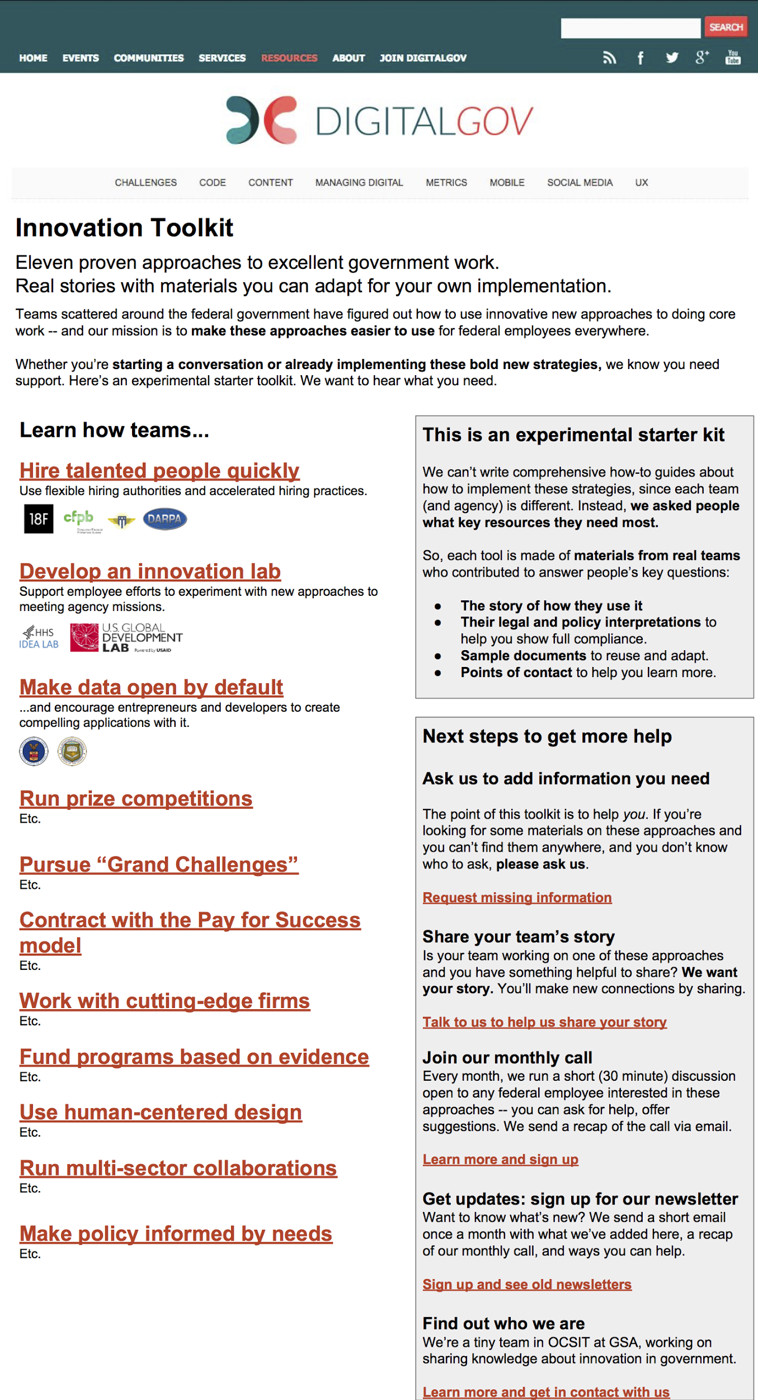

### Search-engine-friendly public mini-site within DigitalGov.gov that seeks out and publishes targeted content meeting expressed needs

**Challenges this solves:** There is a lot of useful information that people want to know about these approaches that isn’t available anywhere online; it’s currently stuck in people’s heads or on people’s hard drives and only transferred through one-to-one conversations. There has to be a place online to collect the available information and write down the contents of people’s heads.

**How it addresses the challenge:** This would provide an ongoing research and publication loop that adds valuable content to the public web, iteratively addressing specific needs (rather than needing to be a complete toolkit upfront). The maintainer would specifically go seek out both the user needs and how to solve them, including through interviewing subject matter experts.

**What challenges it does not tackle:**

A public website by itself (even with a maintainer) is only a partial way to serve people’s needs: it needs to also have social infrastructure built around it to lead people to read it and participate in developing it, since most of them don’t already regularly go check DigitalGov.gov as a resource.

By itself, this also doesn’t serve people’s core need of connecting to each other effectively. Any public website for a website about innovative practices would have the problem that there are many useful stories and pieces of advice that people can’t write down publicly, either due to people’s own hesitations (such as being concerned about giving the wrong advice) or the hesitations of legal staff.

**Specific things this mini-site would do:**

* Each section would have sub-sections **focusing on resources provided by individual teams** (somewhat like case studies), rather than trying to draw abstracted information from those collected stories. There is no one true solution that works for all teams; these approaches are very context-sensitive. Instead of trying to provide general how-to information, the website can help individual teams/agencies tell their individual stories as examples and role models. (This is why the mockup shows team/agency logos -- and this helps with immediate visual “social proof”, showing through visual storytelling that this is a broadly interagency project.)
* The mini-site content would be focused on: **stories (case studies/examples)**, **compliance/legal/policy information**, **model/sample documents**, and **points of contact** -- these are the key resources people have asked for.
* It’s fine if the content is **piecemeal and “incomplete”** at launch, rather than telling comprehensive stories -- some of the target audience needs only a few key pointers to get started and then they’ll flesh out the rest of the research themselves, customized to their own needs. Focus on efficient, iterative content: provide as-needed “shortcuts” rather than trying to write comprehensive books, and flesh that out in directions that respond to user questions.
* The site would **clearly ask for help** and contributions -- it would state this very upfront as part of the design.
* The site would use **direct, bold, action-oriented language and design**. This would respect and reflect the voice and style of the people using this site. Summarizing our interview experiences: they are highly capable people who speak directly and get things done quickly -- it’s unlikely that they need a site with hand-held explanations, lots of decorations, or stock photos. They need resources that are carefully organized and dense with valuable information.
* The site would be structured to **let people dive straight into a tool** and then explore related documents from there. It’s not likely that they care about seeing links to internal documents for *all* the tools at once. They often care about one specific tool at a time and going deep on it.
* Start with posting **public documents** to avoid the headaches of authorization and to increase search engine friendliness. Some documents wouldn’t be able to be posted publicly; the curator could get permission to keep them in reserve for a potential non-public gov-only site later.
* The mini-site could also have a list of **“top viewed documents”** (such as in the card format in the wireframe image on the right) that would provide an easy entry point for browsing for people who aren’t sure yet whether they’re interested in any specific approach.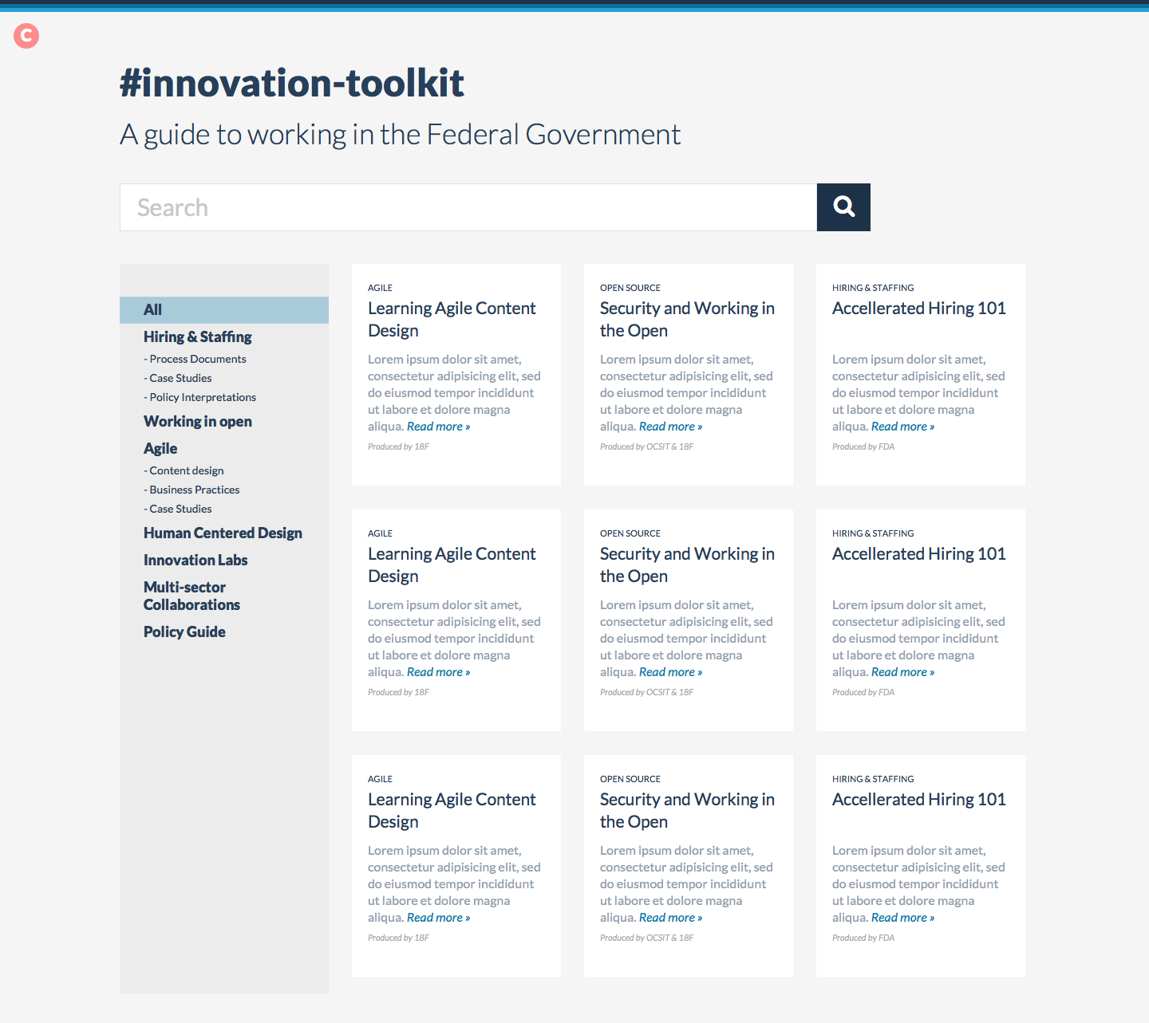

**Each page would contain:**

* **Seed it before launch** with “low hanging fruit” content from friendly and willing teams. Many of the people we talked to (and 18F itself) have a bunch of useful content in our heads (and our Google Drive) that other people want and that we could fairly easily share if asked -- we just haven’t yet invested much organized effort in publishing information about our operations for fellow federal employees. Getting asked to do that by an Innovation Toolkit project could be a good catalyst.
* **Behind-the-scenes encouragement to link back:** For each agency/team that participates in contributing content to a toolkit tool, the site curator should strongly encourage the team to link to this toolkit page from a place on the agency website where federal employees looking for that kind of information might find it (such as linking to the hiring top talent info from a special section on the [Join 18F page](https://pages.18f.gov/joining-18f/), the [Join CFPB page](http://www.consumerfinance.gov/about-us/careers/), and the [Join DARPA page](http://www.darpa.mil/work-with-us/employment-at-darpa)).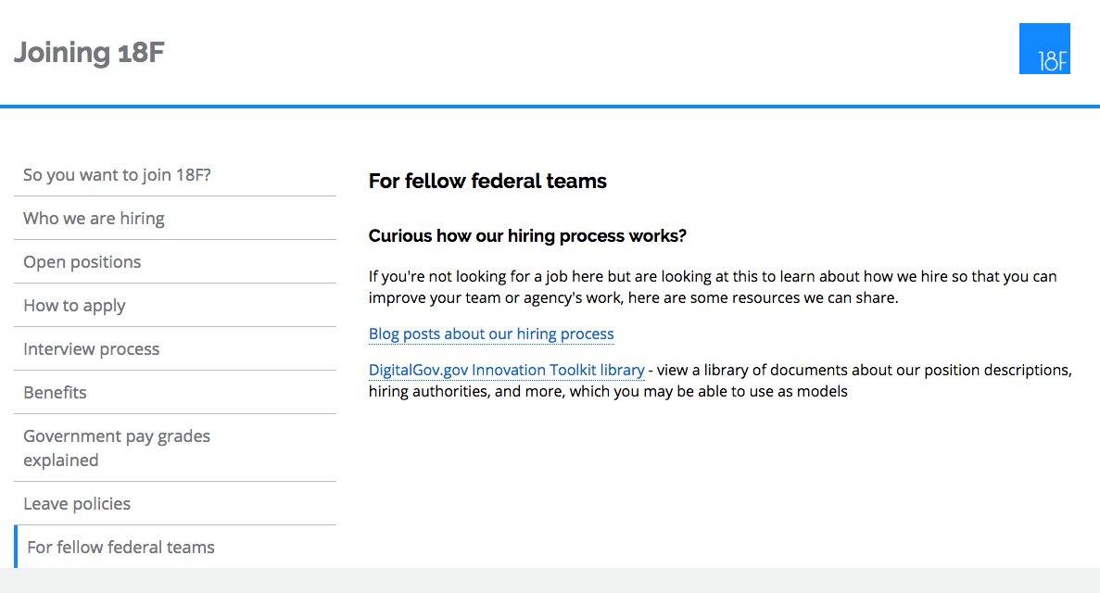
  + This would be a key part of driving relevant people with questions to the toolkit -- since a logical place to look for information about an agency’s operations is on the agency’s website. Integration into the agency/team website would also encourage that team to remember to occasionally update the linked information rather than entirely forgetting about it.
* The points of contact are an essential part of distributing knowledge, but it’d be easy to accidentally overburden those volunteers with a stream of questions from people -- which means that few of them might sign up to be listed as just a name and email address. Instead of that kind of simple listing, the site could provide a format that **encourages each potential point of contact to outline strong boundaries around their available time and interests**, in a friendly and very detailed format like this:
  + ***Name:*** *Britta Gustafson*
  + ***Expertise:*** *I’m happy to answer questions from people at any agency who are trying to work on releasing more of their custom-developed code as open source software projects with lively communities. I’m a content designer at 18F at GSA; I have a background in open source community management and technical writing, including a specific interest in iOS security. I’m not a software developer; my specialties are that I’m familiar with how 18F publishes open source software, and I can also informally explain the cultural, legal, and technical norms of the broader outside-government free and open source software community.*
  + ***What to read first:*** *Before reaching out to me, I strongly recommend reading* [*blog posts I’ve written for 18F*](https://18f.gsa.gov/team/britta-gustafson/) *and* [*my comments on OMB’s draft source policy*](https://github.com/WhiteHouse/source-code-policy/issues?q=is%3Aissue+is%3Aclosed+author%3Abrittag)*. They may already provide answers to your questions.*
  + ***Preferred ways to contact me:*** *If you can use Slack chat and have a topic you can discuss publicly, feel free to join* [*#opensource-public on the 18F Slack chat*](https://chat.18f.gov/)*, which is where my 18F coworkers and I talk about open source with anyone interested (inside and outside the federal government). Otherwise, if you have a .gov email address, feel free to email* [*britta.gustafson@gsa.gov*](mailto:britta.gustafson@gsa.gov) *and we can find a time to chat on the phone.*
  + ***Available amount of time:*** *I can probably make time for a 20-30 minute phone call with you. If you’d like more extensive open source advice, I’d suggest* [*inquiring with 18F about a consulting engagement*](https://18f.gsa.gov/hire/)*.*
  + ***Things I want to learn from you:*** *I’m generally interested in getting a broader perspective of the challenges federal staff face when trying to develop custom code as open source; discussing this with you could help inform my work in general.*

**Ways to measure effectiveness:**

* Are people visiting the site?
* Are people asking for more information and more details?
* Are people volunteering to contribute information?
* Is anyone in the Points of Contact lists getting contacted? Are they getting contacted too often?
* Are there useful documents that can’t get published due to legal/communications review since the site is public -- and are there any that would be able to be published on a hypothetical non-public government-only sister site?

**Questions/hypotheses/risks to consider:**

* Building a website by itself, even with a curator, still risks the “if you build it they will come” fallacy. It still would need investment in outreach to be really effective.
* The DigitalGov site information architecture isn’t optimized right now to help people find resource pages like this one. It would need some investment in reorganizing its content (especially its [Resources page](http://www.digitalgov.gov/resources/)) in order to help people find this sub-section (even if they know about it already).
* It’s not clear whether people would volunteer to be listed as Points of Contact on a public site even if they were encouraged to write down strict boundaries.
* The four-part content concept (examples/case studies/narratives, legal/policy interpretations, sample documents, points of contact) is fairly ambitious for a project with eleven approaches. It could take a long time to gather even just some seed content for all eleven before a launch. I would trim out “sample documents” if a three-part concept were more manageable to think about, since people can get sample documents by talking to people.

### Non-public (government-only) site to accompany the public Innovation Toolkit siteScreen Shot 2016-05-27 at 8.46.32 AM.png

**Challenges this solves:**

If innovative teams aren’t willing to share certain kinds of documents publicly, or aren’t willing to list their contact information publicly -- or really aren’t willing to share much publicly -- the Innovation Toolkit could have an accompanying non-public resource library linked from the public mini-site.

**How it addresses the challenge:**

The mockup on the right shows a hypothetical case that would address the problem of people running into difficulty getting permission to publicly share sample/model documents -- this part of the Toolkit is a MAX.gov shared page behind authentication so that only federal employees can see it.

This mockup does not display how a Point of Contact library could fit into the non-public site, but that could also easily happen.

**What challenges it does not tackle:**

This does not tackle the challenge of building an outreach/communications system to fully support the strong need that people have for networking and connection with other people across agencies who are working on innovative approaches.

This specific mockup shows a MAX.gov site, but even though MAX.gov is accessible to all federal employees as a document sharing system, it is not commonly used or preferred by many people. We heard that people rarely log into it and feel somewhat frustrated by the system in general. There would also be other options - for example using MAX.gov authentication to help people log into a non-public part of DigitalGov.gov.

The cloud.gov team at 18F happens to be also seriously exploring a way to help people across the federal government sign into cloud.gov accounts using their own specific agency credentials rather than needing a government-wide authentication system, and they could potentially offer this authentication system to other products like this toolkit.

**Specific things this would do:**

This concept is based on preliminary research results that publishing documents non-publicly means that the burden to share them is reduced for some teams -- for example, that at least a communications department doesn’t have to review and potentially redact them. So, a non-public site could make it much easier for people to share deeply useful materials in a scalable way -- not just via email.

This mockup prioritizes sample/model documents since our preliminary research showed that people informally share these kinds of documents to help each other already (such as internal memos, position descriptions, and internal guidebook pages) -- and that they can demonstrate a variety of types of vital information including **how to comply with legal requirements**, **how to convince authorities of the value of these approaches**, and **how to measure the effectiveness of these approaches**. They could be used by staff as concrete proof to authorities/supervisors that other agencies have already successfully implemented these approaches. They also minimize labor costs on the part of the sharing team/agency (once you have permission) since sharing them doesn’t require researching/writing new materials.

MAX.gov allows people to upload documents themselves, which might reduce labor for the curator (the curator wouldn’t have to manually post documents, unlike the likely manual content management system for submitted documents on the public Toolkit site). The curator would still have to arrange and sort the documents to make sure they were presented in a useful and well-prioritized way.

Very similar to the accompanying public toolkit site, this would need:

* **A curator:** This needs a person who can be the “face” of the library. They maintain the overall content and vision, and they’re a point of contact for questions.
* **The virtual library itself:**
  + **Clear and inviting statement of goals, scope, and process.**
  + **Thoughtful organization centering user needs.**
  + **Seed documents from 18F:** 18F could likely provide a starter kit of valuable information from our own experience, which would attract people to this resource. For example, we could likely provide parts of our staff handbook, some of our IAAs, GSA memos that helped establish 18F, information about our hiring authorities, etc. Much of this is information we intend to publish publicly already, and some of it is public already, but we don’t really have an organized way of sharing it with fellow federal employees.
  + **Seed documents from as many other agencies as possible:** Get buy-in from other teams who can contribute useful documents before publicizing it broadly, such as USDS.
  + **A “wanted” list:** Maintain a list of types of documents that people want to see, and invite people to add to that list.
  + **Statement of cadence of updates:** So that people know how often to check back for more.
* **Search engine-friendly supporting material on DigitalGov.gov:** Since MAX.gov is non-public, DigitalGov.gov needs to have a thorough explanation of that resource (with all the appropriate keywords) so that federal employees can discover it via search engines and then log into MAX.gov.
* **Pre-built policies to support adding material:** People will need to get permission from authorities to add material to this resource. Explain to people how to argue to get permission for it from their agencies.

**Ways to measure effectiveness:**

* Measure whether visits and participation are increasing or decreasing
* “Net promoter score” surveys

**Questions/hypotheses/risks to consider:**

* Would people find enough value in this idea to contribute to it?
* Would people be willing to share this kind of thing non-publicly?
* Would people be *unwilling* to share this kind of thing publicly?
* Are people willing to use MAX.gov if the resources are valuable enough?
* Would people hear about it who are looking for this kind of thing?
* Could we get enough buy-in to have a seed library that was valuable?

### Run an accompanying community of practice with facilitation to support ongoing networking and contribution

**Challenges this solves:**

People have a core need to connect with other people who take innovative approaches to government work, especially people working on similar projects in other agencies. They deeply enjoy and are inspired by meeting other people who care about the approaches that they also care about. This means the toolkit needs to have some community infrastructure that welcomes new people and keeps up ongoing participation and energy -- a community of practice.

**How it addresses the challenge:**

* Outreach with a regular cadence of events:
  + **Stream of updates:** This resource needs to provide a stream of updates (likely via email) so that people know when it’s modified with new documents. MAX.gov already has this feature, if we can teach people how to use it. Or we might want a monthly email newsletter written by the curator of the library, if resources allow.
  + **Monthly short event:** Run a monthly call-in event (30 min) discussing the resources - ask people to attend it to talk about **what they want** and **what they might be able to offer**.
  + **Regular blog posts:** Write DigitalGov blog posts about this resource, at a cadence of every few months, to remind people that it exists and share any new information that *can* be public.
    - Cross-post to 18F blog to reach a broader audience of federal employees.
    - All blog material should be integrated into the main toolkit as well.
  + **Listservs:** Work with all the relevant DigitalGov listservs to promote all of these things and keep them in people’s minds. For example, the curator can keep an eye on the mailing lists to share links to relevant resources if people are asking for them, and to learn about what people need.
    - There could also be a listserv specific to the Innovation Toolkit that would be run with an active host who would proactively ask questions once a week. This would add more structure and direction to topics while creating a safe space and replicable structure for people to share ideas, get feedback and ask questions.
    - This listserv could also recap the monthly call-in event.

**Ways to measure effectiveness:**

* Are people participating in the events and listserv?

**Questions/hypotheses/risks to consider:**

* Would people interested in the various approaches have enough in common to make a Toolkit-specific listserv/event make sense?
* Will members of the listserv will be willing to prioritize time for a regular meetup?
* What is the right frequency?
* Would people be ok with a written recap of the meeting?
* Would members proactively share links?